HAUGHTON PARISH COUNCIL NEWS – JULY 2022
Haughton’s Jubilee Picnic! Thank you ☺
- Haughton’s Jubilee Picnic took place on Sunday 5th June with an excellent turnout from villagers. The weather wasn’t great and rain prevented the vintage car display from taking place but every other aspect of the day went ahead as planned. A Community Foundation for Staffordshire grant for £500 had been secured by the Parish Council to assist with the costs of the event. The Parish Council were helped by many of the village groups and the day wouldn’t have been possible without the help of these as well as many individuals – too many to mention! Cake was plentiful, fun was had by all and Pimms was enjoyed with the hymns to round off the day – we trust Her Majesty would have approved of the celebrations! 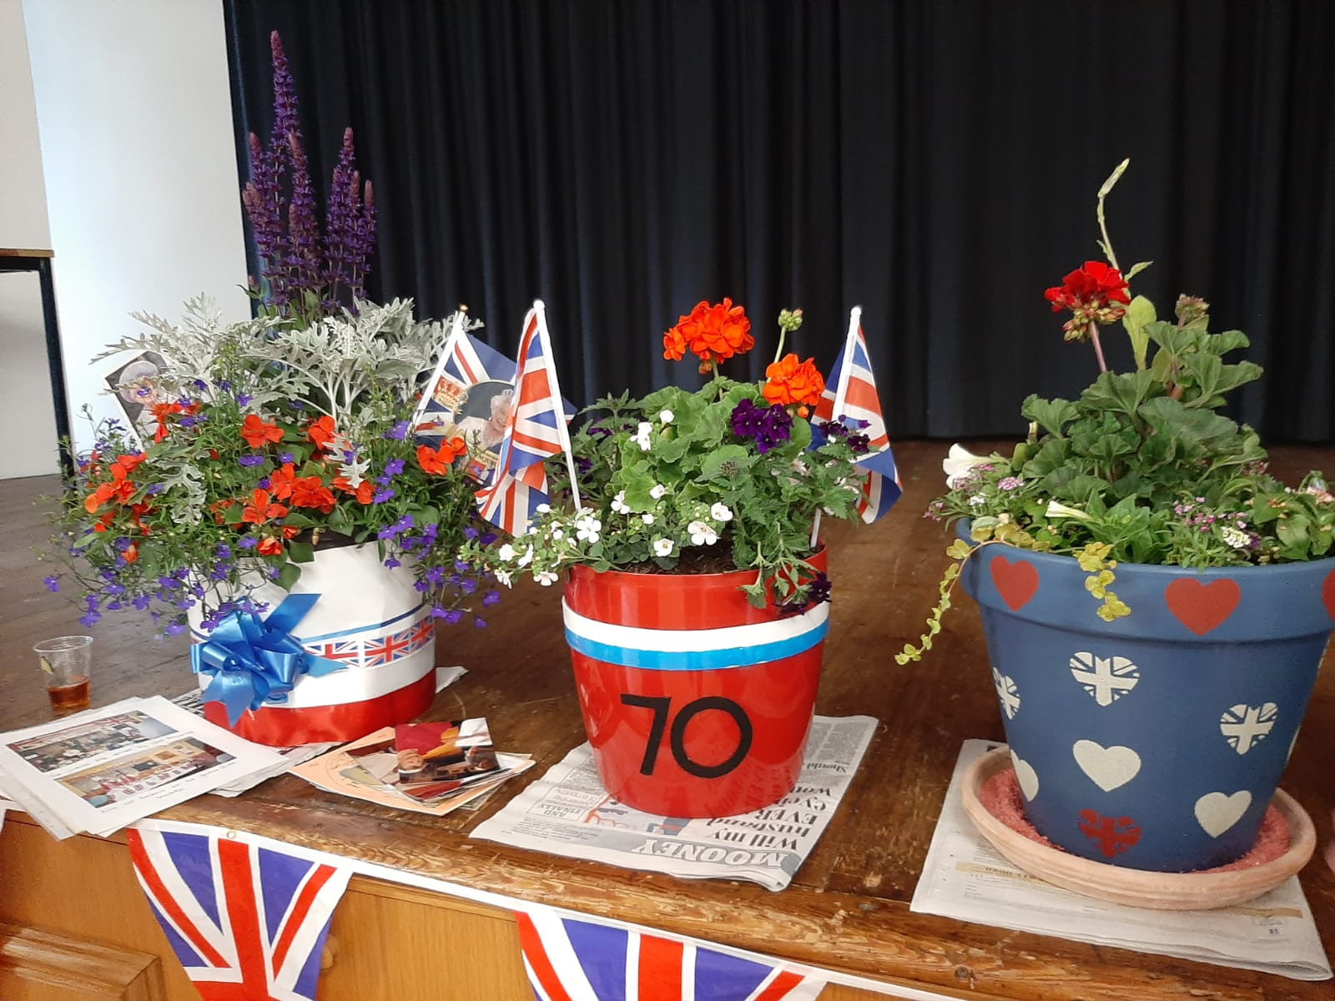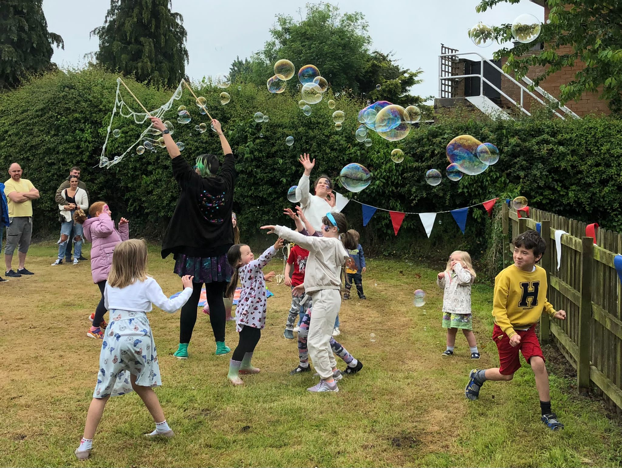
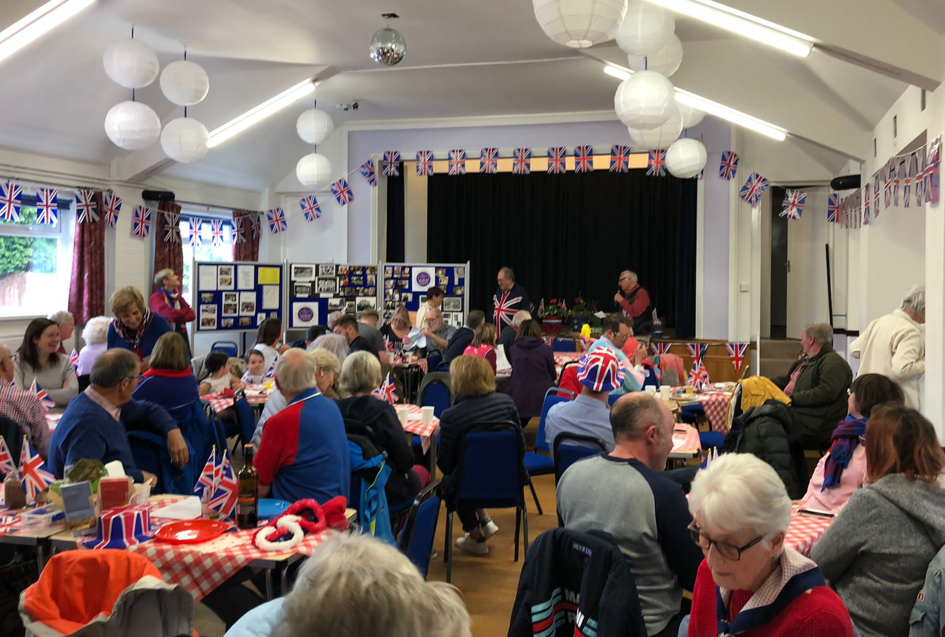

FURTHER INFORMATION – HAUGHTON PARISH COUNCIL Copies of the agendas and minutes of the previous meetings along with details of your Parish Councillors can be found on the Parish Council website www.haughtonpc-staffs.org.uk additionally, minutes and agendas are also posted on the notice board on the corner of Royds Close. The next meeting of Haughton Parish Council will take place on Monday 25th July, 7pm at Haughton Village Hall.
For further information on any of the above please contact Clerk to Haughton Parish Council, Suzanne Potts by email on clerk@haughtonpc-staffs.org.uk

